

BAHIR DAR UNIUERSITY
BAHIR DAR INSTITUTE OF TECHNOLOGY(BIT)
FACULITY OF COMPUTING
DEPARTMENT OF INFORMATION TECHNOLOGY (bed)

Practical Lab Documentation: Oracle Linux 8 Installation in Virtual-box

Student Information

Name:Abham mengist

ID: 1600616

Date: 27/04/2018 E.C

Course: Operating Systems Lab

Introduction
Virtualization allows running multiple operating systems on one computer. Oracle Linux is an enterprise Linux system used for servers and cloud. This lab installs Oracle Linux 8 on Windows using Virtual-box.

Objectives
- Install Virtual-box on Windows
- Create virtual machine for Oracle Linux 8
- Install Oracle Linux 8
- Configure system and user
- Test the installation

Requirements

i. Hardware
- Computer with Windows 10/11
- 8 GB RAM total
- 50 GB free space
- Internet connection

ii. Software
- Windows 10/11 (64-bit)
- Oracle VM VirtualBox 7.0
- Oracle Linux 8.9 ISO file
- VirtualBox Extension Pack

Installation Steps

Prepare Windows Computer
Check Virtualization Support
- Open Task Manager (Ctrl+Shift+Esc)
- Click Performance tab
- Look at "Virtualization" - must say "Enabled"
- If disabled, enter BIOS and enable it

Download Software
- Open web browser
- Go to https://www.virtualbox.org
- Click "Download"
- Download "Windows hosts" version
- On same page, download Extension Pack
- Go to https://yum.oracle.com/oracle-linux-isos.html
- Download Oracle Linux 8.9
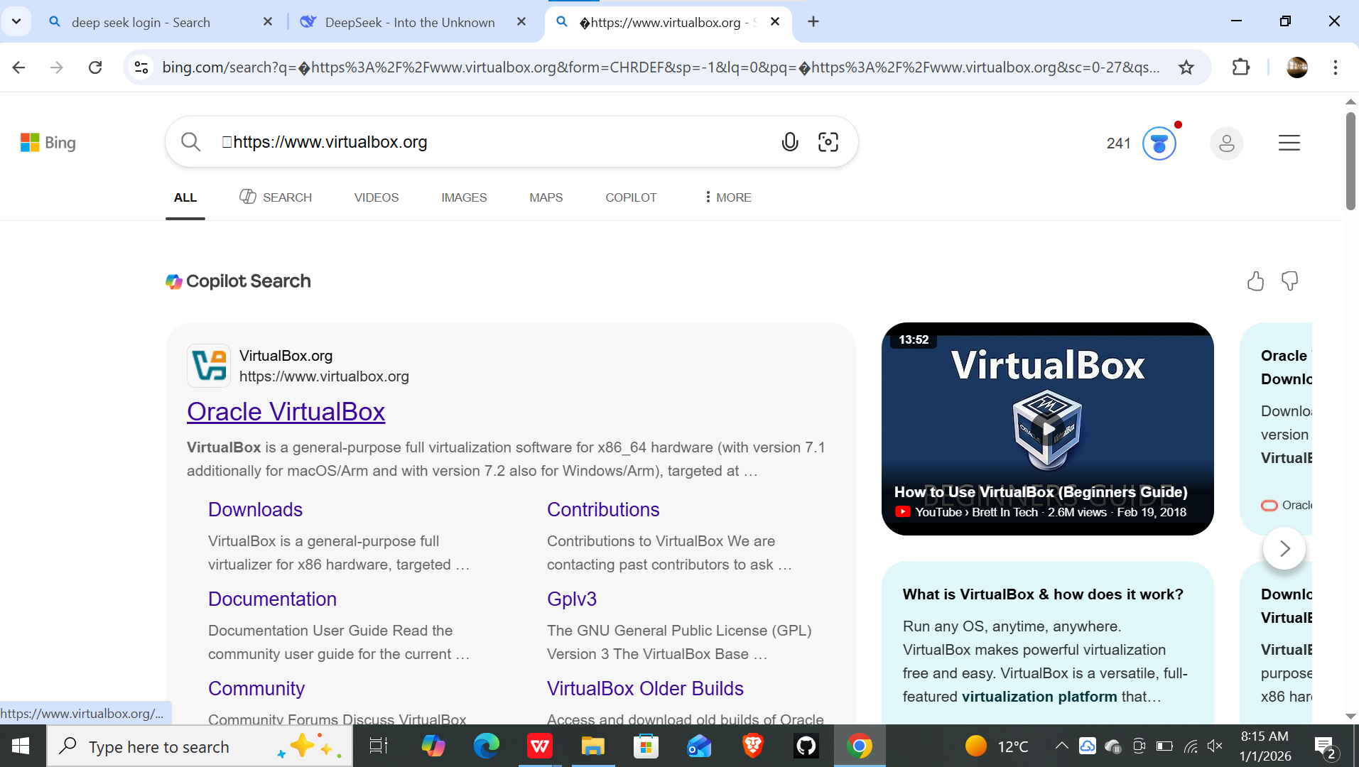
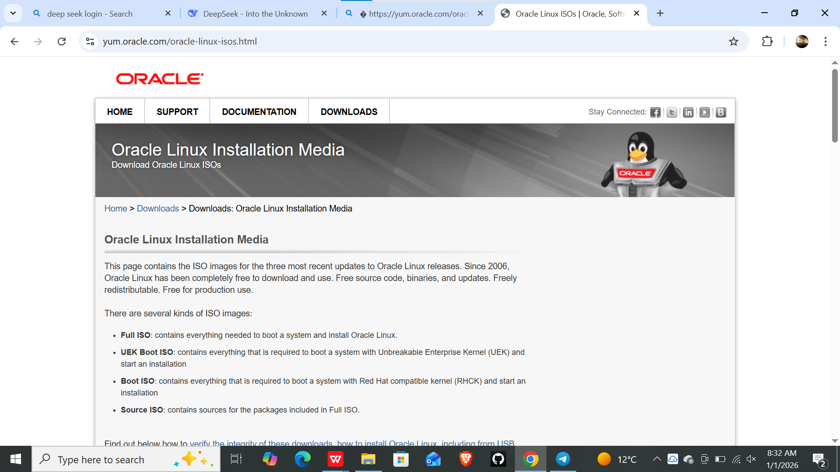

Install Virtual-box

- Find downloaded VirtualBox file
- Right-click → Run as administrator
- Click Next → Next → Next
- Click Install
- Wait for installation
- Click Finish

Install Extension Pack
- Open VirtualBox
- File → Preferences → Extensions
- Click green + button
- Select Extension Pack file
- Click Install → I Agree

Part 3: Create Virtual Machine
- In VirtualBox, click "New"
- Enter name: Oracle Linux 8 - [Abrham-mengist]
- ISO Image: Select Oracle Linux 8.8 file
- Type: Linux
- Version: Red Hat (64-bit)
- Click Next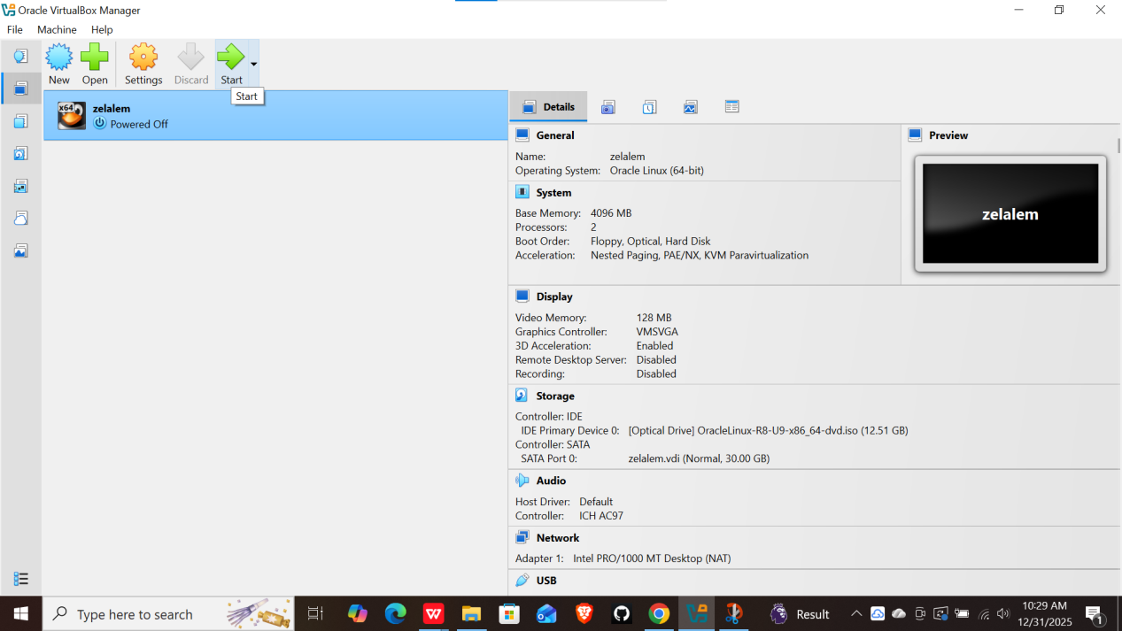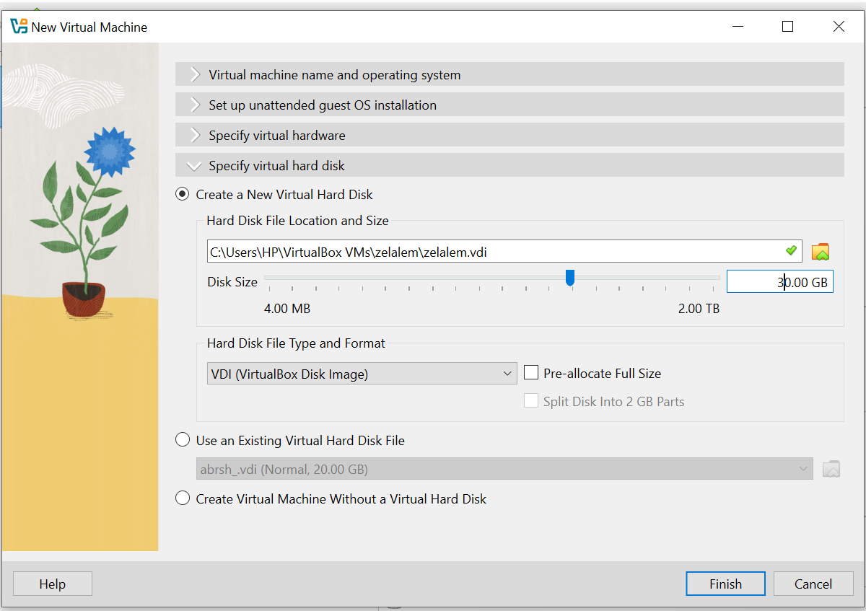

Set Resources

- Memory: 4096 MB (4 GB)
- Click Next
- Hard disk: Create virtual hard disk
- Click Create
- File type: VDI
- Storage: Dynamically allocated
- Size: 30 GB
- Click Create

Configure Settings

- Select VM → Settings
- System → Processor: Set to 2
- Display → Video Memory: 128 MB
- Check "Enable 3D Acceleration"
- Click OK

Part 4: Install Oracle Linux 8

Start Installation

- Select VM
- Click Start
- Press Enter to install
- Select language: English → Continue

Configure Installation

      - Click "Installation Destination"
      - Click Done (use automatic partitioning)
      - Click "Software Selection"
      - Select "Server with GUI"
      - Click Done
      - Click "Network & Host Name"
      - Turn ON Ethernet
      - Click Done

Create User Account
- Click "User Creation"
- Full Name: Abrham Mengist
- Username: Abrham
- Password: set password
- Check: "Make this user administrator"
- Check: "Require a password"
- Click Done

Set Root Password
- Click "Root Password"
- Enter password
- Confirm password
- Click Done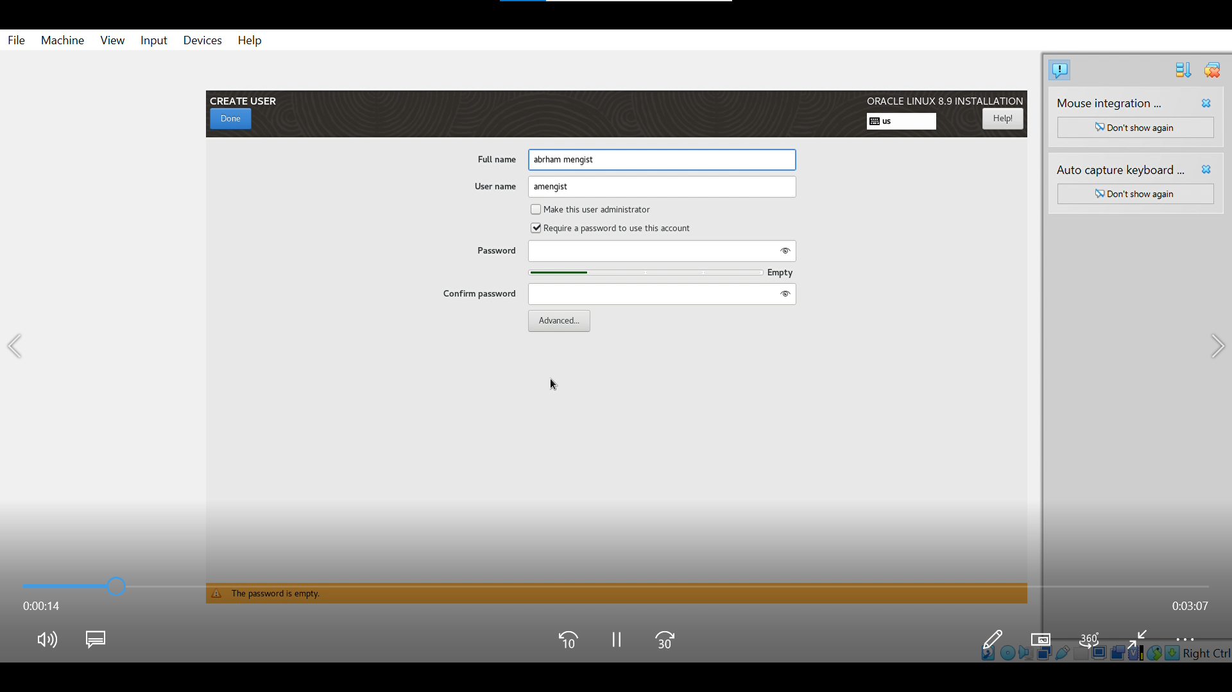

Begin Installation

- Click "Begin Installation"
- Wait 15-25 minutes
- When finished, click "Reboot System"

Part 5: First Boot Setup
Initial Setup
- Accept license agreement
- Click "Finish Configuration"
- Select your user
- Enter password
- Click Sign In
- Complete setup wizard

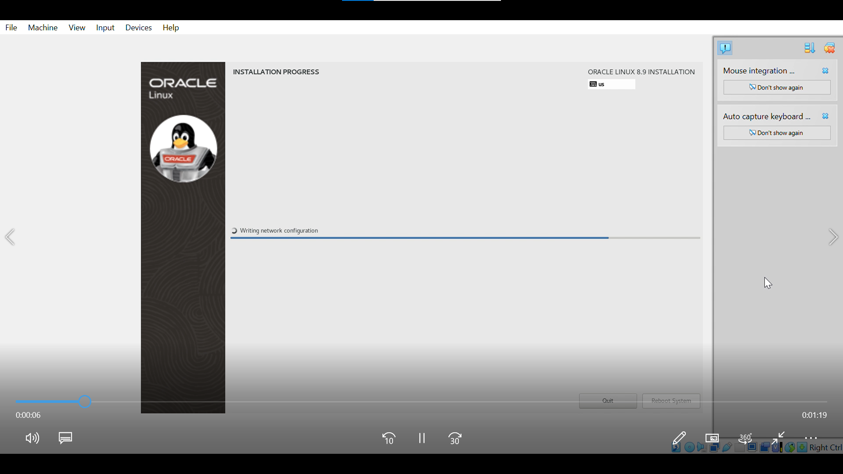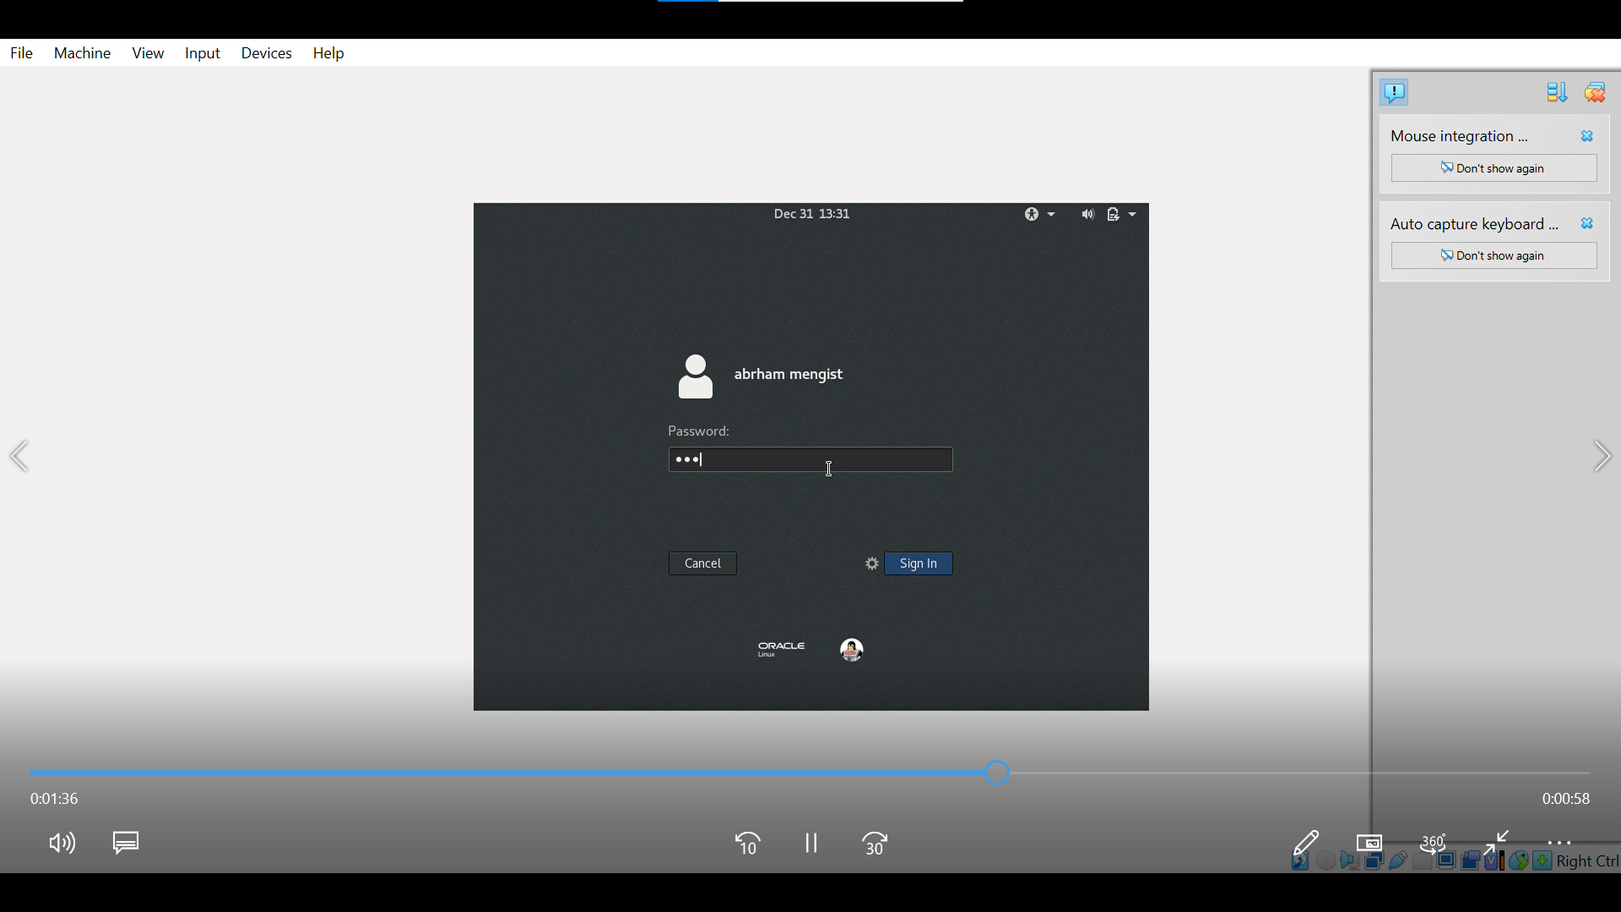Update System
          - Open Terminal
          - Type: sudo dnf update -y
          - Press Enter
          - Type password when asked
          - Wait for update
          - Type: sudo reboot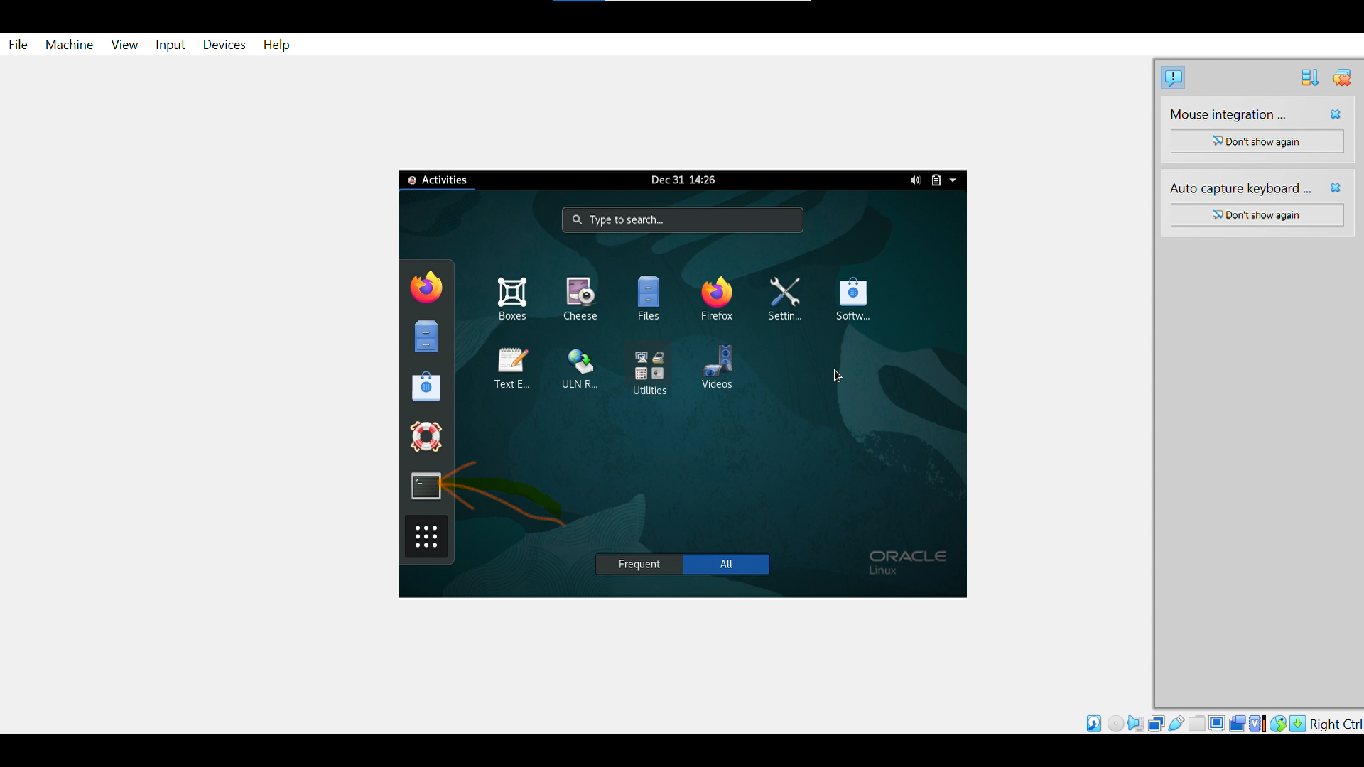

Part 6: Install Guest Additions

- In VirtualBox menu: Devices → Insert Guest Additions CD
- Open Terminal
- Type: sudo dnf install -y gcc make perl kernel-devel
- Press Enter
- Type: sudo mount /dev/cdrom /media
- Type: cd /media
- Type: sudo ./VBoxLinuxAdditions.run
- Wait for installation
- Type: sudo reboot

Issues Faced

Problem 1: "VT-x is disabled" error
Cause: Virtualization not enabled in BIOS
Fix: Enter BIOS, enable Intel VT-x
Problem 2: Installation stuck
Cause: Software selection issue
Fix: Choose "Minimal Install" first
Problem 3: No internet
Cause: Network adapter not connected
Fix: Enable network in settings
Problem 4: Small screen
Cause: No Guest Additions
Fix: Install Guest Additions

Solutions
1 BIOS Settings:
- Restart computer
- Press F2 during boot
- Find CPU settings
- Enable Virtualization
- Save and exit

Network Fix:
sudo nmcli connection up "Wired connection 1"
Storage Fix:
- Check 30 GB space available
- Use automatic partitioning

Filesystem Support

oracle Linux 8 uses:

- Main: XFS filesystem

Why XFS for Oracle Linux
- Good for large files
- Can grow while running
- Fast for databases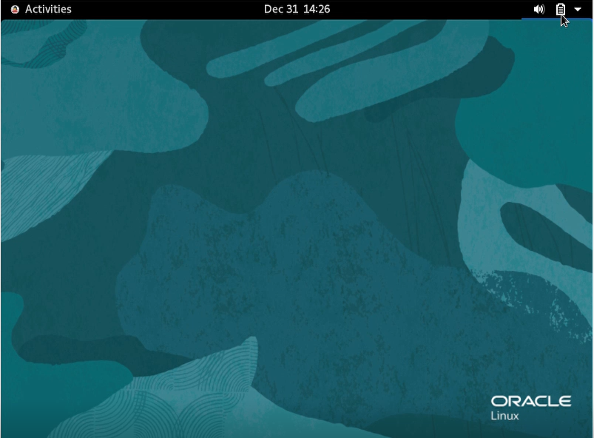
- Default for enterprise Linux

"XFS was specifically chosen as the default file-system for Oracle Linux because it optimizes performance for enterprise workloads commonly involving large database files, virtual machine images, and cloud storage. Its design integrates seamlessly with Logical Volume Manager (LVM), enabling flexible storage management for server environments. XFS maintains data integrity through journaling while providing excellent parallel I/O performance crucial for multi-user and multi-threaded database applications typically deployed on Oracle Linux systems."

Other supported:
- ext4 (like Windows NTFS but for Linux)
- FAT32 (for USB drives)
- NTFS (read Windows disks)

Advantages and Disadvantages of oracle Linux

Advantages:
- Safe Environment: Isolated from host Windows system
- Enterprise Features: Real-world Linux server experience
- Snapshot Capability: Save VM state before making changes
- Costco-effective: Free to use for learning and development
- portability: Virtual machine can be copied and moved

Disadvantages:
- Performance Overhead: 10-15% slower than physical installation
- Resource Intensive: Requires significant RAM and storage
- Graphics Limitations: Limited 3D acceleration support
- Network Complexity: Requires configuration for optimal connectivity
- Storage Space: Consumes substantial disk space for VM files

Conclusion
Oracle Linux 8 has been successfully installed and configured within Oracle VM Virtual-box on a Windows host system. The virtual machine is fully operational with proper network connectivity, updated system packages, and user account configuration. This setup provides a complete enterprise Linux environment suitable for learning system administration, software development, and server management without affecting the host Windows operating system.

Future Outlook / Recommendation

Recommendations:
- Practice daily with Linux command line interface
- Install and configure web servers (Apache/Nginx) for hands-on experience
- Learn about Linux security features including firewalld and SE-Linux
- Experiment with container technologies like Pod-man and Docker
- Explore Oracle Linux 9 for newer features and improvements

Virtualization

Virtualization in Modern Operating Systems
Virtualization is the process of creating virtual (software-based) versions of computing resources, including hardware platforms, operating systems, storage devices, and network resources. It allows multiple operating systems to run concurrently on a single physical machine.

Why Use Virtualization?
- Testing & Development: Safe environment for software testing and experimentation
- Server Consolidation: Run multiple server applications on one physical server
- Disaster Recovery: Easy backup and restoration of virtual machines
- Legacy Application Support: Run older operating systems on modern hardware
- Cost Reduction: Reduce hardware, power, and cooling expenses
- Educational Purposes: Learn different operating systems without additional hardware

Documentation Completed By: Abrham Mengist
Student ID: 1600616
Completion Date: 27/04/2017 E.C
Host System: Windows with Oracle VM VirtualBox
Guest System: Oracle Linux 8.8
Status: Installation and Documentation Complete

